ADVANCED SOFTWARE SERVICES, INC
CONTACT MARKETING USER MANUAL

Title Page

Table of Contents 1
Function Keys 2
Browse Contacts 3
View Contacts 4
Mail List 5
Browse Mail List 6
View Mail List 7
Reports List Request 8
Reports Labels 9
Mail Merge File 10
Import Contacts 11
Download to Laptop 12
Upload Contacts 13

ADVANCED SOFTWARE SERVICES, INC
FUNCTION KEYS

The following describes the standard function keys:

BRWS = The browser which is a list of records in the file. This is functionally equivalent
to the find option of our standard package.

VIEW = View record provides the ability to ADD, CHANGE, DELETE and UPDATE
an individual record.

SORT BY = The selections at the bottom of the browser which will sort the list in alphabetic order.

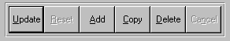

Update = Updating the current record.
Reset = Reset the current record.
Add = Add a record.
Copy = This will copy the existing record.
Delete = Delete the current record displayed on the screen.
Cancel = Canceling the information that was entered.
Save = Save the record


Takes you to the end end first record. | Takes you back one record at a time. | Moves forward one record. | Last current record.
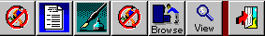

Search F2 | List F3 | Notes F4 | Misc. Fields F5 | Brows F6 | Viewer F7 | Exit F12
ADVANCED SOFTWARE SERVICES, INC
CONTACT MARKETING (BROWSE CONTACTS)

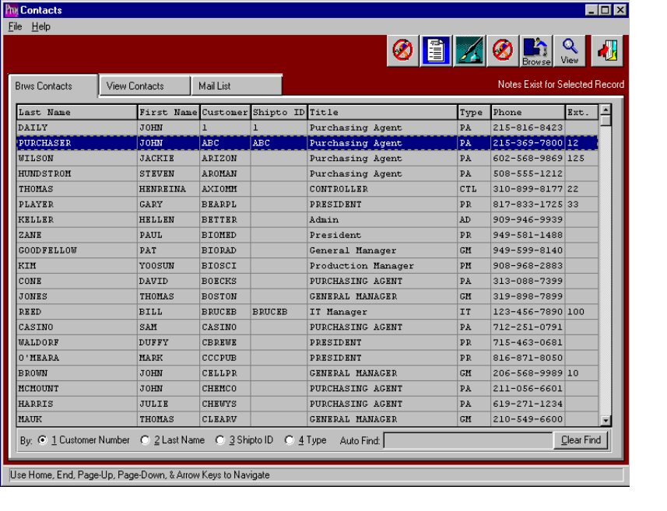

BROWSE CONTACT NAME

The contact name browser can be sorted by customer number, last name, Shipto ID, or type. To view the items for a particular record, simply double click on the contact name or press the folder to view contacts. To sort the list by customer number, last name, shipto ID, or type; click the desired option at the bottom of the browser and the list will be resorted in the selected order. The browser shows the contacts Last Name, First Name, Customer Number, Shipto ID, Title, Type, Phone, and Extension. The icons at the top of the browser provide additional capabilities. The icons with the fountain pen provide notes for each contact. Each note records the user initials, date, and description of the note and a full-page of text for each note. Unlimited notes may be defined for each record. The browse icon will provide an immediate access to the browser by customer part number. The view icons provide a list as a quick reference list.
ADVANCED SOFTWARE SERVICES, INC
CONTACT MARKETING (VIEW CONTACTS)
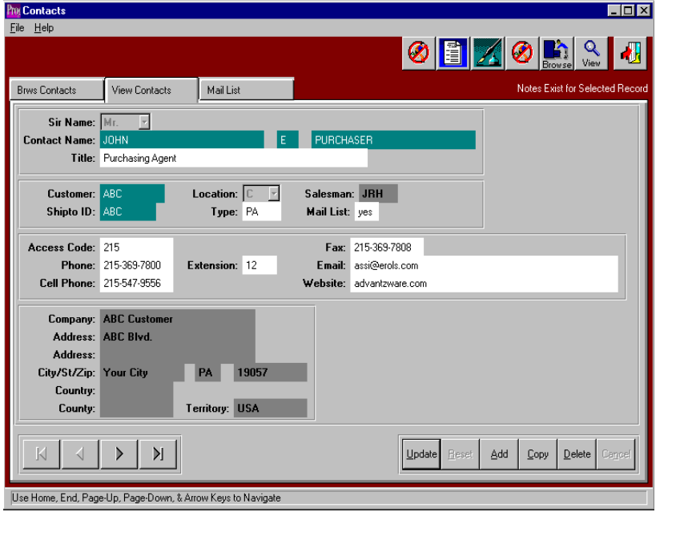

VIEW CONTACTS

To add, change, delete, or view a contact, the folder called VIEW CONTACTS must be selected. To add new contact, click the ADD button or press the Alternate key and the letter A together. To move from field to field, as with all Windows-based programs, the TAB key should be utilized.

Sir Name - a drop down list is available to select your option. Valid options are Mr., Ms., Mrs., Dr., or Blank.

Contact Name – First, Middle Initial, and Last Name of the contact.

Title - Contact’s position title.

Customer Number – This field has an F1 Lookup. This lists all existing and valid customer numbers. Once a Customer number is entered, the company name, address, city, state, zip, country, county, and territory information is pulled into the contact information.

Location – Enter the location of the contact. Select “C” for Customer Location, “S” for Shipto Location, or leave blank.

Salesman - Salesman number for the contact. This will default to the salesman number in the customer file.

Shipto ID - This field has an F1 Lookup. This lists all existing and valid Shipto ID numbers for the selected customer.

Access Code – Enter the Contacts Phone access code.

The ENTER key or the SAVE key are used to save the new contact information.

ADVANCED SOFTWARE SERVICES, INC
CONTACT MARKETING (MAIL LIST)

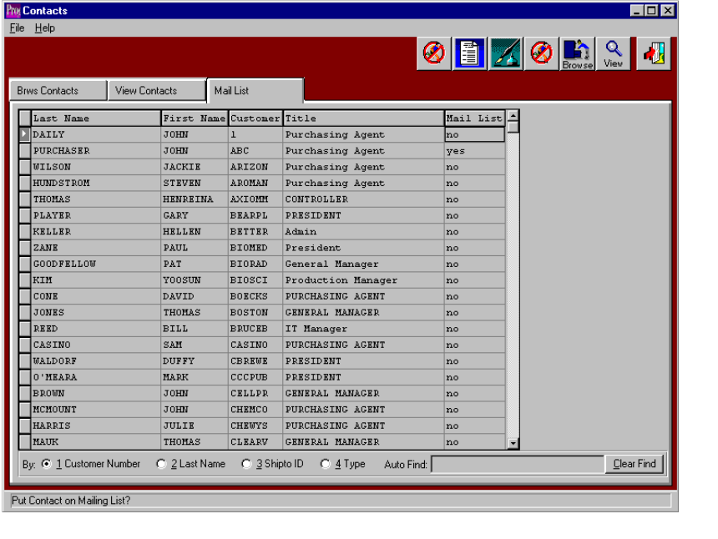

MAIL LIST

The Mail List Broswer is similar to the Contact Browser. To sort the list by customer number, last name, shipto ID, or type the desired option at the bottom of the browser and the list will be resorted in the selected order. The mail list shows the contact’s Last Name, First Name, Customer Number, and Title. The mail list column will have yes or no. This transfers from the View Contact screen, which is entered by the user. If the mail list is yes, this contact will appear on a contact list report. If the mail list is no, the contact will not appear on a contact list report. The icons at the top of the mail list provide additional capabilities. The icons with the fountain pen provide notes for each contact. Each note records the user initials, date, and description of the note and a full-page of text for each note. Unlimited notes may be defined for each record. The browse icon will provide an immediate access to the browser by customer number. The view icons provide a list as a quick reference list.
ADVANCED SOFTWARE SERVICES, INC
MAIL LIST MAINTENANCE (BROWSE MAIL LIST)
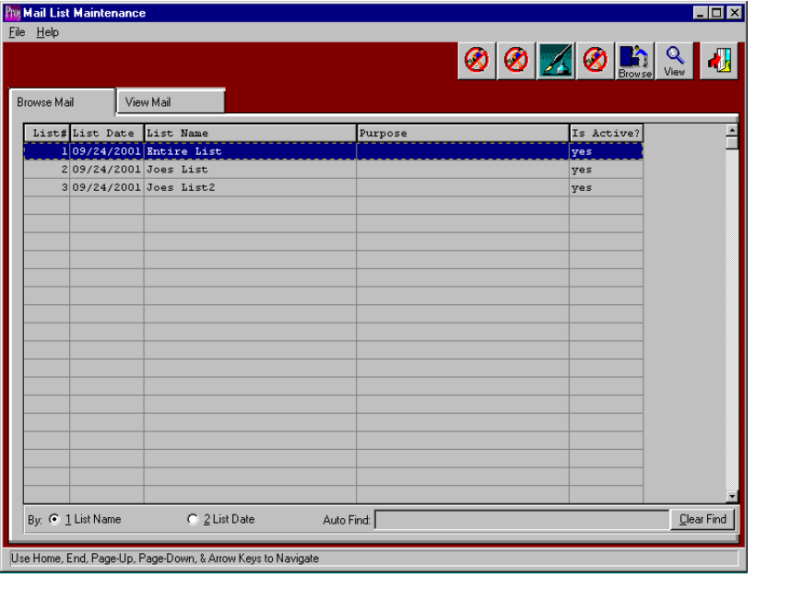

MAIL LIST

The Mail List Broswer is similar to the Contact Browser. To sort the list name or list date, simply click the desired option at the bottom of the browser and the list will be resorted in the selected order. Unlimited mail marketing lists may be created by extracting names from the contact mail list or by copying an existing list. Lists may be created for specific sales representatives, sales promotions, and board price increases, customer relations and more. The icons at the top of the mail list provide additional capabilities. The icons with the fountain pen provide unlimited notes for each list perhaps describing the reason for the list. Each note records the user initials, date, and description of the note and a full-page of text for each note. Unlimited notes may be defined for each record. The browse icon will provide an immediate access to the browser by customer number. The view icons provide a list as a quick reference list.
ADVANCED SOFTWARE SERVICES, INC
MAIL LIST MAINTENANCE (VIEW MAIL LIST)
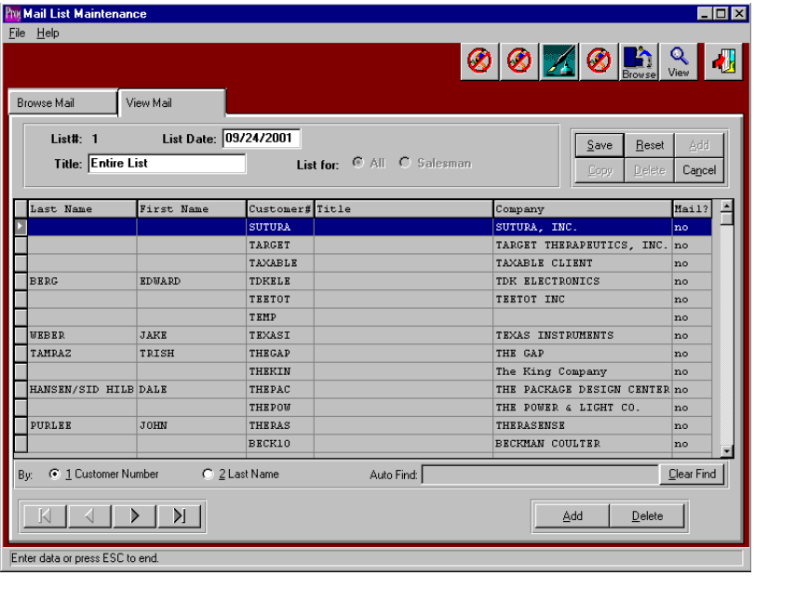

VIEW MAIL LIST

The View Mail folder allows the creation of unlimited mail marketing lists by extracting names from the contact mail list or by copying an existing mail list. Lists may be created for specific sales representatives, sales promotions, and board price increases, customer relations and more. Once created, list may be printed for telemarketing, or the list may be downloaded to a mail merge Microsoft word document or the list may be sorted by zip code to print mailing labels. The icons at the top of the mail list provide additional capabilities. The icons with the fountain pen provide unlimited notes for each list perhaps describing the reason for the list. Each note records the user initials, date, and description of the note and a full-page of text for each note. Unlimited notes may be defined for each record. The browse icon will provide an immediate access to the browser by customer number. The view icons provide a list as a quick reference list.

The ADD button at the top right of the screen is used to create new lists by downloading names from the master contact list. After pressing the ADD Button, the List for toggles allows selecting a specific salesman or the entire list. When selecting a salesman, the contact list will download all contacts, which have that salesman’s code assigned. Once the new has been created, the SAVE button must be pressed to save the new list. The ADD and DELETE buttons on the bottom left will add or delete individual contacts from the specific list. Likewise, the Yes/No flag may be toggled with the click of the mouse. Only contact with the YES flag will print on reports or download to a file or label.

THE DELETE button at the top of the screen will delete the entire mailing lists, but will not delete the names from the master contact list. Likewise, the COPY button will copy an existing mailing list, which had been previously downloaded from the contact list. The UPDATE button allows changing the date or name of a particular list. The CANCEL button simply cancels the current function without saving the transaction.

ADVANCED SOFTWARE SERVICES, INC
CONTACT MARKETING (REPORTS – LIST REQUEST)

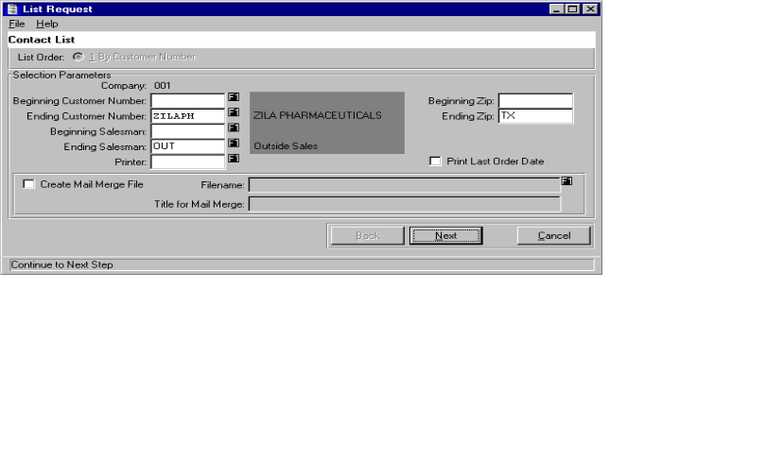

LIST REQUEST

This Contact List Request will allow you to print a Contact List. This also allows you to create a Mail Merge File, that you can use to create a mail merge with the Microsoft word processing software program. This report can be run a number of different ways. It can be run for a selected range of customers, a selected range of salesmen, or a selected range of zip codes. This report may also include the last order date for the customer. To create a Mail Merge file, you must place a check in the Create Mail Merge File checkbox. A filename must also be specified. This will be the file name used in your word processing software.

ADVANCED SOFTWARE SERVICES, INC
CONTACT MARKETING (REPORTS – LABELS)

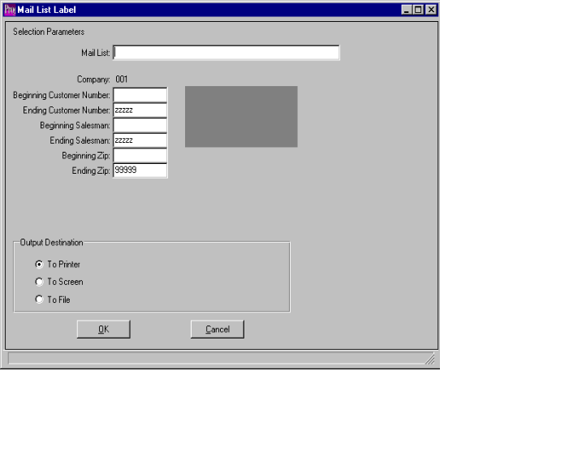

MAIL LIST LABELS

This Mail list label program will allow you to print mailing labels for any mail list. This report selection menu allows a number of different selections. Within a particular mailing list, it can be run for a selected range of customers, a selected range of salesmen, or a selected range of zip codes. The F1 key will provide a list of mailing lists to be selected. The labels will print three contacts across and was designed to print on standard laser mailing labels 1x2-5/8. The labels may be purchased from QUILL Corporation at phone number 800-789-1331. The part number is 7-32200 and is described as Ink Jet Labels.
ADVANCED SOFTWARE SERVICES, INC
MAIL LIST REPORTS (MAIL MERGE FILE)

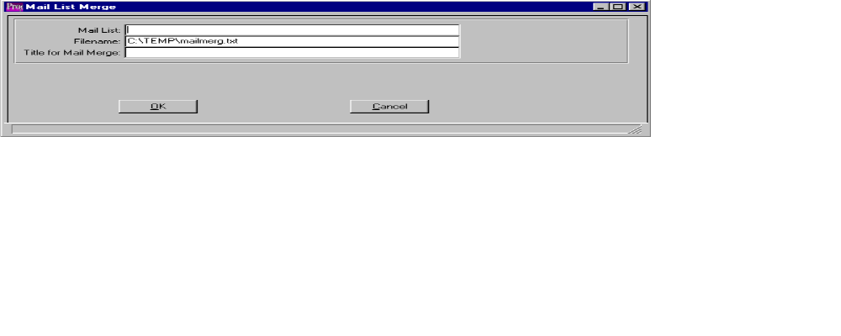

MAIL MERGE

This Mail Merge program will allow you to create a Microsoft mail merge document for any mail list. The F1 key will provide a list of mailing lists to be selected. The mail merge document will be output to the file location defined when creating the mail merge document. Likewise, the user and give and title for the merge document. Once a merge document is created, the program will automatically create a note for each contact on the mailing list.

ADVANCED SOFTWARE SERVICES, INC
CONTACT MARKETING (FILE MAINTENANCE - IMPORT CONTACTS)

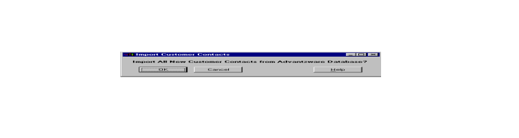

IMPORT CONTACTS

This selection will download your Advantzware Customer file to Contact Marketing. This will overwrite your current file and replace with an updated file. This will include any new, or any changes to existing contacts, added to Advantzware Customer file, but not yet entered into Contact Marketing.

ADVANCED SOFTWARE SERVICES, INC
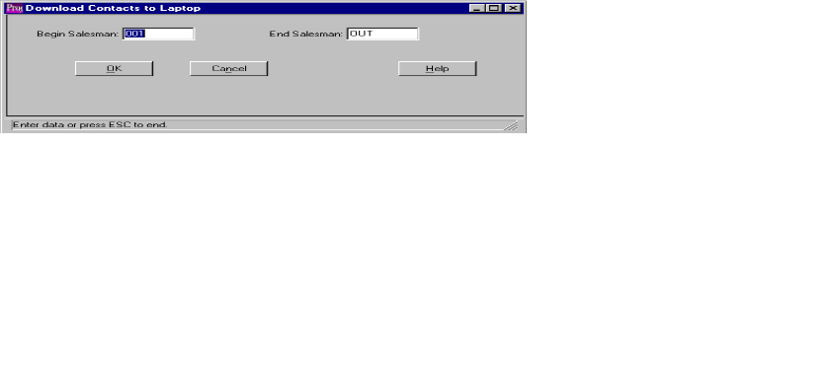CONTACT MARKETING (FILE MAINTENANCE – DOWNLOAD TO LAPTOP)

DOWNLOAD CONTACTS TO LAPTOP

This selection will download all contact and contact information from the server to a laptop.

To achieve the ability to download, the laptop must have Progress Personal Database along with stand alone Contact Marketing Module.

This selection includes a security feature that begins at the time the salesman is logged on. This feature allows the salesman to print only the contacts belonging to his salesman ID. The security must first be set up on the server to allow for downloads. On the server, user groups must be set up. One group will be called SMAN, which will include the entire salesman log on ID’s. You will also need to set up one user group for each salesman listed in the SMAN user group. In the salesman user group, you will put the salesman’s number. Whatever number you put here, that salesman will be able to download all contacts for that number. You may have more than one number for a salesman. For example, you may set up the Sales Manager to download all contacts for all salesmen. You may also set up territories. For example, Salesman number one may download contacts for salesman one, two, and three, but not salesman number four.

ADVANCED SOFTWARE SERVICES, INC
CONTACT MARKETING (FILE MAINTENANCE – UPLOAD CONTACTS)
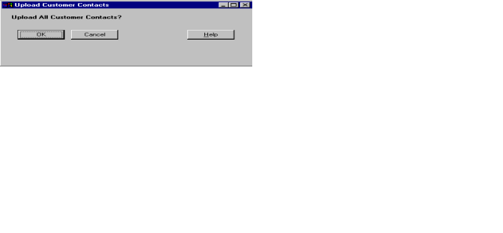

UPLOAD CUSTOMER CONTACTS

This selection will load all contact information from a laptop to a server.

This gives salesman the ability to add additional notes to contact information, without logging into the server. The salesman can make any changes or additions to his contact list. Then, the salesman can use this selection to load all the changes to the server database. This is a convenient option to save time and eliminate entering the same information on the laptop and on the server.

